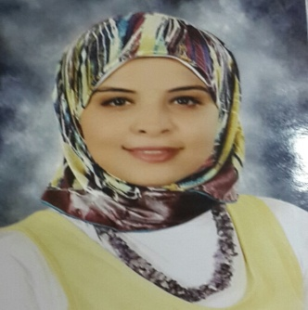
Menna-t-allah Abdallah Ahmed Hassan
Birth: 6/9/1994
Address: El Omal city ,El Azhar pharmacy ,Qena
Languages: English, Arabic (native)
Tel: 01094942486 / Home: 0965329466
mennaabdallah6994@gmail.com

PROFESSIONAL SUMMARY
Demonstrator at Clinical Pharmacy Department , Faculty of Pharmacy, Assuit University.

EDUCATION AND TRAINING
- 2017-2018 work as a community pharmacist at Al-Azhar pharmacy.
- 2017 graduated as clinical Pharmacist with 3.96 GPA , Pharmacy College, Assiut, Egypt.
- 2015 Member of Egyptian pharmaceutical students’ federation
- 2014 Training for a year at El Azhar Pharmacy, Qena.

SKILLS HIGHLIGHTS

- Expert understanding of Medicare and Medicaid processes.
- Exceptional patient care and interaction.
- Efficient and accurate.
- Strong decision-making ability.
- Strong time management.
- Playing on Piano.
- Travelling.
- Works under stress.

Courses and certificates
- Sketch your future.
- Cancer chemotherapy
- 3 dimensions of scientific research
- OTC course
- ICDL certificate
- Second clinical pharmacy training day on 8th Oncology conference 2017

PROFESSIONAL EXPERIENCES .
- 15th EPSF National Symposium.
- The second annual scientific day of clinical pharmacy unit at Urology-Nephrology Hospital.

